**Minimize spread factor, but keep overlap [1.1, .9, .5, .3, 0]**

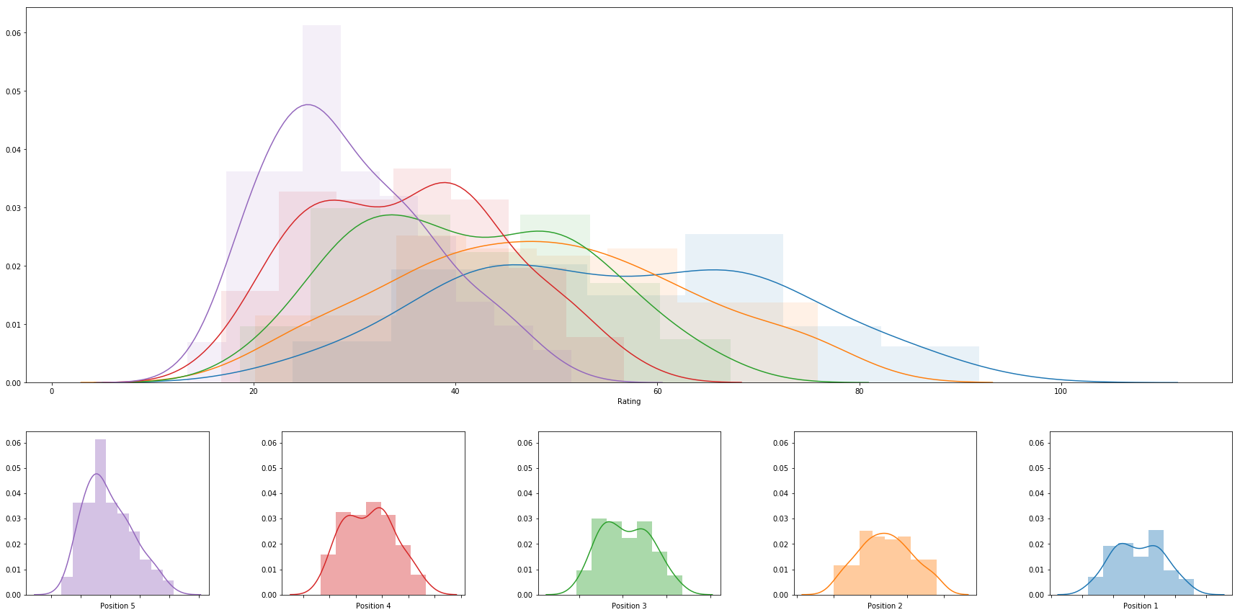

|  |  |  |  |  |  |  |  |
| --- | --- | --- | --- | --- | --- | --- | --- |
|  | **rank** | **name** | **college** | **division** | **rating** | **primary position** | **date** |
| **0** | 1 | Abril Bustamante | USC | DI | 91.85574833758078 | 1 | 2018-05-05 |
| **1** | 2 | Megan McNamara | UCLA | DI | 85.68830103025263 | 1 | 2018-05-06 |
| **2** | 3 | Nicole McNamara | UCLA | DI | 85.68830103025263 | 1 | 2018-05-06 |
| **3** | 4 | Tina Graudina | USC | DI | 85.30608463955055 | 1 | 2018-05-05 |
| **4** | 5 | Victoria Paranagua | Florida State | DI | 84.63875043779751 | 1 | 2018-05-05 |
| **5** | 6 | Emily Maglio | Hawaii | DI | 83.92634585903411 | 1 | 2018-05-06 |
| **6** | 7 | Ka'iwi Schucht | Hawaii | DI | 83.92634585903411 | 1 | 2018-05-06 |
| **7** | 8 | Claire Coppola | LSU | DI | 80.92166880002124 | 1 | 2018-05-04 |
| **8** | 9 | Kristen Nuss | LSU | DI | 80.92166880002121 | 1 | 2018-05-04 |
| **9** | 10 | Sasha Karelov | Long Beach State | DI | 79.69165638427937 | 1 | 2018-04-28 |
| **10** | 11 | Vanessa Freire | Florida State | DI | 77.40354917976627 | 1 | 2018-05-05 |
| **11** | 12 | Nele Barber | Long Beach State | DI | 77.1340515300022 | 1 | 2018-04-28 |
| **12** | 13 | Madeline Mertz | Tulane | DI | 77.10947077373696 | 1 | 2018-04-21 |
| **13** | 14 | Kaylie Mchugh | Tulane | DI | 77.10947077373696 | 1 | 2018-04-21 |
| **14** | 15 | Sunny Villapando | Stanford | DI | 76.142842977333 | 1 | 2018-04-27 |
| **15** | 16 | Katie Smith | South Carolina | DI | 75.92808144028166 | 2 | 2018-05-04 |
| **16** | 17 | Sarah Sponcil | UCLA | DI | 75.55708661294109 | 2 | 2018-05-06 |
| **17** | 18 | Lily Justine | UCLA | DI | 75.55708661294102 | 2 | 2018-05-06 |
| **18** | 19 | Corinne Quiggle | Pepperdine | DI | 75.17306206608866 | 2 | 2018-05-05 |
| **19** | 20 | Deahna Kraft | Pepperdine | DI | 75.17306206608866 | 2 | 2018-05-05 |
| **20** | 21 | Morgan Martin | Hawaii | DI | 74.49147285816615 | 2 | 2018-05-06 |
| **21** | 22 | Katie Horton | Florida State | DI | 74.36040117659714 | 2 | 2018-05-05 |
| **22** | 23 | Rachel Nieto | Long Beach State | DI | 73.42048135935859 | 2 | 2018-04-28 |
| **23** | 24 | Teegan Van Gunst | Georgia State | DI | 73.39513308907883 | 1 | 2018-04-21 |
| **24** | 25 | Lea Monkhouse | Hawaii | DI | 73.29297257892036 | 2 | 2018-05-06 |
| **25** | 26 | Sammy Slater | USC | DI | 73.20384269517884 | 2 | 2018-05-05 |
| **26** | 27 | Hailey Luke | Florida State | DI | 73.09316642901193 | 2 | 2018-05-05 |
| **27** | 28 | Federica Frasca | FIU | DI | 72.90501598765388 | 1 | 2018-05-04 |
| **28** | 29 | Margherita Bianchin | FIU | DI | 72.90501598765388 | 1 | 2018-05-04 |
| **29** | 30 | Mima Mirkovic | Cal | DI | 72.37865421297336 | 1 | 2018-04-28 |
| **30** | 31 | Annika Van Gunst | Georgia State | DI | 72.23830499997139 | 1 | 2018-04-21 |
| **31** | 32 | Jessica Wooten | Houston Baptist | DI | 72.06205845599675 | 1 | 2018-04-22 |
| **32** | 33 | Aeriel Horton | Houston Baptist | DI | 72.06205845599675 | 1 | 2018-04-22 |
| **33** | 34 | Madalyn Roh | Pepperdine | DI | 71.22252629762717 | 1 | 2018-05-05 |
| **34** | 35 | Brook Bauer | Pepperdine | DI | 71.22252629762717 | 1 | 2018-05-05 |
| **35** | 36 | Terese Cannon | USC | DI | 70.95333425134518 | 2 | 2018-05-05 |
| **36** | 37 | Dani Barton | Utah | DI | 70.25301577171898 | 1 | 2018-04-27 |
| **37** | 38 | Adore Anae | Utah | DI | 70.25301577171898 | 1 | 2018-04-27 |
| **38** | 39 | Alexia Inman | Cal | DI | 69.43700644476372 | 1 | 2018-04-28 |
| **39** | 40 | Tia Miric | Cal Poly SLO | DI | 69.31916853215942 | 1 | 2018-04-28 |
| **40** | 41 | Torrey Van Winden | Cal Poly SLO | DI | 69.31916853215942 | 1 | 2018-04-28 |
| **41** | 42 | Shannon Williams | South Carolina | DI | 68.50163096527349 | 1 | 2018-05-04 |
| **42** | 43 | Ali Denney | South Carolina | DI | 68.50163096527349 | 1 | 2018-05-04 |
| **43** | 44 | Emily Sonny | Cal Poly SLO | DI | 68.38104889566395 | 2 | 2018-04-28 |
| **44** | 45 | Olivia Macdonald | Arizona | DI | 67.89510012280974 | 1 | 2018-04-27 |
| **45** | 46 | Natalie Anselmo | Arizona | DI | 67.89510012280974 | 1 | 2018-04-27 |
| **46** | 47 | Carly Kan | Hawaii | DI | 67.23418376211039 | 3 | 2018-05-06 |
| **47** | 48 | Sam Manley | Cal Poly SLO | DI | 67.21286296524373 | 2 | 2018-04-28 |
| **48** | 49 | Kimmy Gardiner | Washington | DI | 67.04764007428452 | 1 | 2018-04-28 |
| **49** | 50 | Jordan Anderson | Washington | DI | 67.04764007428452 | 1 | 2018-04-28 |
| **50** | 51 | Morgan Hughes | Saint Mary's | DI | 66.78784714663301 | 1 | 2018-04-21 |
| **51** | 52 | Payton Rund | Saint Mary's | DI | 66.78784714663301 | 1 | 2018-04-21 |
| **52** | 53 | Sammee Thomas | Stetson | DI | 66.51035590754032 | 1 | 2018-04-21 |
| **53** | 54 | Darby Dunn | Stetson | DI | 66.51035590754032 | 1 | 2018-04-21 |
| **54** | 55 | Jessica Gaffney | Cal | DI | 66.13172787221993 | 2 | 2018-04-28 |
| **55** | 56 | Laurel Weaver | Hawaii | DI | 65.83412814531121 | 3 | 2018-05-06 |
| **56** | 57 | Cadie Bates | South Carolina | DI | 65.42438076833815 | 2 | 2018-05-04 |
| **57** | 58 | Morgan Hentz | Stanford | DI | 64.88763733039289 | 2 | 2018-04-27 |
| **58** | 59 | Amelia Smith | Stanford | DI | 64.88763733039289 | 2 | 2018-04-27 |
| **59** | 60 | McKayla Ferris | LMU | DI | 64.77602239776375 | 1 | 2018-04-21 |
| **60** | 61 | Megan Kruidhof | Long Beach State | DI | 64.70192797791465 | 2 | 2018-04-28 |
| **61** | 62 | Courtney Schwan | Washington | DI | 64.67403050033171 | 2 | 2018-04-28 |
| **62** | 63 | Haleigh Nelson | LSU | DI | 64.62973427534567 | 2 | 2018-05-04 |
| **63** | 64 | Sara Putt | Florida State | DI | 64.42763207344804 | 3 | 2018-05-05 |
| **64** | 65 | Savannah Slattery | LMU | DI | 64.3661414185759 | 1 | 2018-04-21 |
| **65** | 66 | Destiny Julye | Washington | DI | 64.35162200198866 | 2 | 2018-04-28 |
| **66** | 67 | Maddy Kline | UNC Wilmington | DI | 64.26441880028909 | 1 | 2018-04-21 |
| **67** | 68 | Nicole Lott | UNC Wilmington | DI | 64.26441880028909 | 1 | 2018-04-21 |
| **68** | 69 | Tiffany Creamer | Georgia State | DI | 64.1072286429245 | 2 | 2018-04-21 |
| **69** | 70 | Devon May | UAB | DI | 63.7958217182834 | 1 | 2018-04-21 |
| **70** | 71 | Hannah Towne | Grand Canyon | DI | 63.55169243187093 | 1 | 2018-04-19 |
| **71** | 72 | Courtney Bowen | Stanford | DI | 63.30014849901101 | 3 | 2018-04-27 |
| **72** | 73 | Brooke Weiner | Georgia State | DI | 63.29280198788859 | 2 | 2018-04-21 |
| **73** | 74 | Kenley Adams | UAB | DI | 63.072604216974774 | 1 | 2018-04-21 |
| **74** | 75 | Iya Lindahl | Cal | DI | 63.05197381138757 | 2 | 2018-04-28 |
| **75** | 76 | Molly Turner | Grand Canyon | DI | 62.90724220092782 | 1 | 2018-04-19 |
| **76** | 77 | Cassie House | TCU | DI | 62.882493129622624 | 1 | 2018-04-15 |
| **77** | 78 | Haven Hill | TCU | DI | 62.882493129622624 | 1 | 2018-04-15 |
| **78** | 79 | Haley Hallgren | USC | DI | 62.55012584764418 | 3 | 2018-05-05 |
| **79** | 80 | Macy Jerger | Florida State | DI | 62.52595726779847 | 3 | 2018-05-05 |
| **80** | 81 | Sara Kovac | LMU | DI | 61.83301434246849 | 2 | 2018-04-21 |
| **81** | 82 | Jessie Prichard | LMU | DI | 61.78667573456912 | 2 | 2018-04-21 |
| **82** | 83 | Taylor Nelson | Cal Poly SLO | DI | 61.40143254596465 | 3 | 2018-04-28 |
| **83** | 84 | Sunniva Helland-Hansen | Stetson | DI | 61.26593433401286 | 2 | 2018-04-21 |
| **84** | 85 | Carly Perales | Stetson | DI | 61.26593433401286 | 2 | 2018-04-21 |
| **85** | 86 | Lindsey Knudsen | Saint Mary's | DI | 61.09669552759499 | 2 | 2018-04-21 |
| **86** | 87 | Emily Bible | Saint Mary's | DI | 61.09669552759499 | 2 | 2018-04-21 |
| **87** | 88 | Savvy Simo | UCLA | DI | 60.54383801756441 | 3 | 2018-05-06 |
| **88** | 89 | Amanda Silva | FAU | DI | 60.13276344691328 | 1 | 2018-04-21 |
| **89** | 90 | Carly Scarborough | FAU | DI | 59.70876635701622 | 1 | 2018-04-21 |
| **90** | 91 | Tarin Mergener | Tulane | DI | 59.26431692003201 | 2 | 2018-04-21 |
| **91** | 92 | Hunter Domanski | LSU | DI | 59.00297475065877 | 3 | 2018-05-04 |
| **92** | 93 | Lan Nguyen | Tulane | DI | 58.777576834963604 | 2 | 2018-04-21 |
| **93** | 94 | Sabryn Roberts | Boise State | DI | 58.51960805874891 | 1 | 2018-04-21 |
| **94** | 95 | Janell Walley | Boise State | DI | 58.51960805874891 | 1 | 2018-04-21 |
| **95** | 96 | Carly Dehoog | Washington | DI | 58.00509860781259 | 3 | 2018-04-28 |
| **96** | 97 | Shayne Mcpherson | Washington | DI | 58.00509860781257 | 3 | 2018-04-28 |
| **97** | 98 | Megan Nash | Central Arkansas | DI | 57.91885852107301 | 1 | 2018-04-22 |
| **98** | 99 | Hayley Tippett | Central Arkansas | DI | 57.91885852107301 | 1 | 2018-04-22 |
| **99** | 100 | Katja Ehlers | College of Charleston | DI | 57.53212310307153 | 1 | 2018-04-21 |